SQL Tutorial
Important Functions on MYSQL: https://www.w3schools.com/sql/sql_ref_mysql.asp
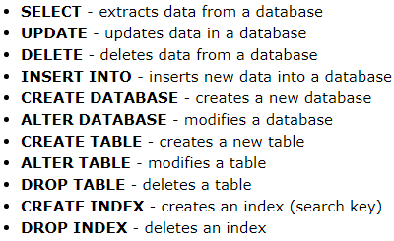

Selects columns: address and city from customers

- * is used only for retrieving a complete table
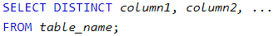
Selects the distinct values from the table

Counts the values in a column

WHERE clause is used to filter records

→ Gave all the name of the customers from mexico
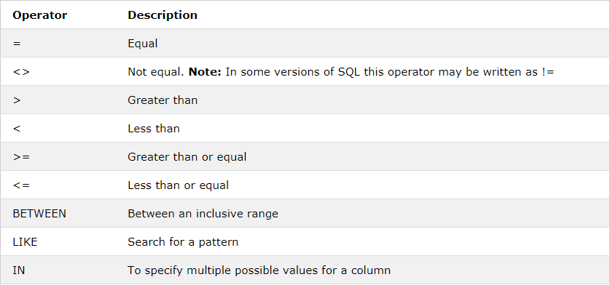
The AND operator displays a record if all the conditions separated by AND is TRUE.
- Eg: Person A is from Country X and from City Y
The OR operator displays a record if any of the conditions separated by OR is TRUE.
- Eg: Person is from Country A or Country B
The NOT operator displays a record if the condition(s) is NOT TRUE.
- Eg: Person is NOT from Country A

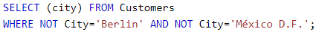
Combining the 2 functions

When not function is involved expand everything imagining it is a negative function in math. A – (B+C) = (A -B) + (A-C)

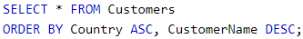
Ordering the country in ascending order, but the customer name for the same
country in descending order

A new row will be produced for this new set of values.
If value isn't insert into a certain column 'null value' will appear



Takes values from the selected columns, then compares the certain column values if null then reports back all the values with the null value too

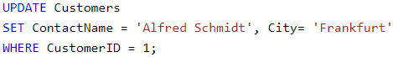
Without a where statement, all values of the table will be updated

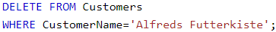
Remember the where statements.

OR ELSE

→ In deleting the whole table

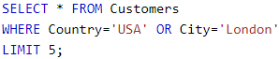
Selecting 5 rows from Customer table where country is USA or city is London
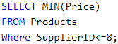
Selecting minimum price from products where supplier ID <=8
MAX is used for maximum price

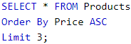
If 3 minimum prices are required, min isn't used, because it will give only one value. Therefore we used ascending, then select the first three values.

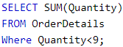
Total sum of quantity values, where quantity < 9

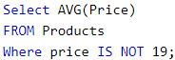
Average Price of products, where the price doesn't equal 19

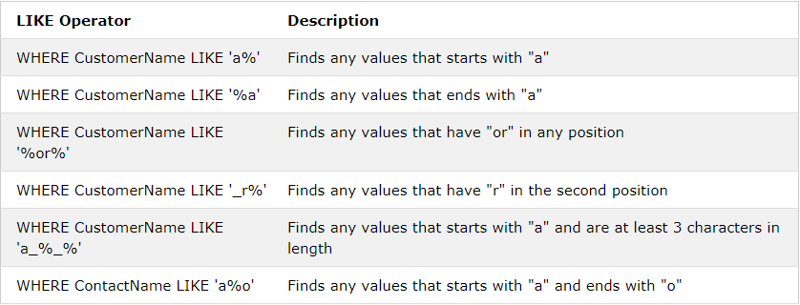
Remember that the values will contain the whole set of words in a column not just an individual word in a group
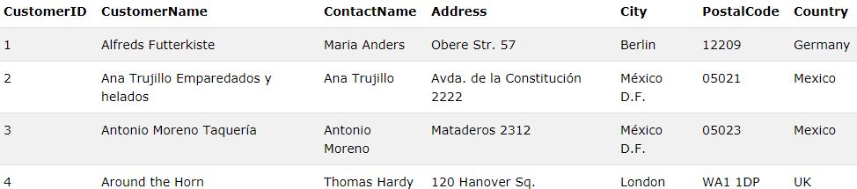

If a%a is applied, “Ana Trujillo Emparedados y helados” customer name won't come. “Antonio Moreno Taquería” will appear since that is that starts with a and ends with a

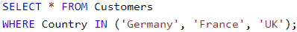
Selecting customers from these countries, replacement for OR function with the same tab values

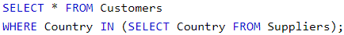
Selecting the customer from the same country as the supplier

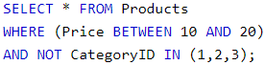
- Not Selecting products between 10 and 20 and not with categoryIDs 1,2 and 3
Taking products between the 2 word's characters

Month, Day, Year
Applying dates

Output is:

Concat chains 2 or more functions together

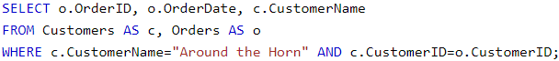
abc.xyz represents that xyz is inside the table abc
Such as the example above. C = customer, therefore customer.orderid represents orderid column in within the customer table

Join
Selecting the columns, from the order table and merging it with customer table by linking the customer ID in order and customer ID in customers as one.

Inner join: Combing the 2 tables with values matching in both
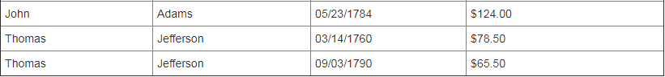
Left join: Even if values don't exist in Table B, it will be merged with null values replacing table B
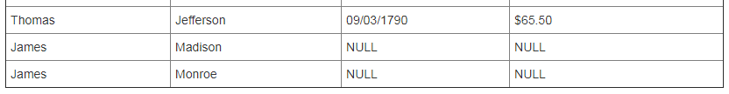

Right join: Even if values don't exist in Table A, it will be merged with null values replacing table A
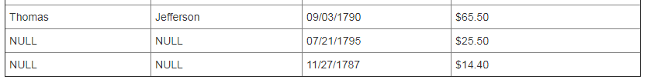
Full join: Combing both tables irrespective if values exist or not in matching tables
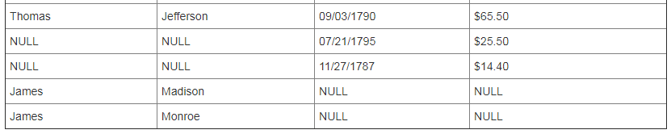
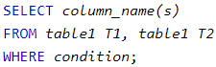
2 columns from the same table will combine to form a single column

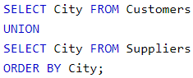
Union combines the 2 individual columns of distinct values from 2 different tables into 1 output column.
- Must have the same data type
- Selected columns in each table must be in the same order
- Both table must have same number of columns

Union All – Same as Union except copies repeated values if present in both tables

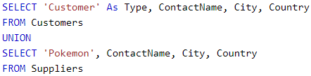

The red words are inserted as the value under type, as it has been programmed above
The rest are used as referred to in the table provided.
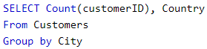
This statement groups the same cities and counts the number. Then 2 columns are produced: containing the number of unique IDs and the relevant country of the city the selected count is of

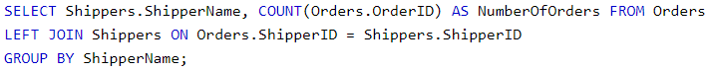
2 columns are created: shipper name and number of orders (based on orderid)
Left join occurs between shippers and orders
Then grouped by shippername

Aggregate functions are used to compute against a "returned column of numeric data" from your SELECT statement. Functions such as sum, min, avg, etc..

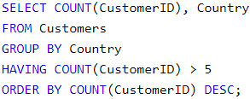
2 columns are created: count from customer ID and Country list
Grouped by country
Having function > 5
Ordered in descending order of count customerID

Having function replaces where function when group count (aggregate functions are used)

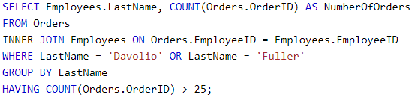

2 columns created, one of the employees' last name and count of the OrderID
Inner Join the employees and orderid based on the employeeID
With last name davolio or fuller
Group by last name
Have count of orderid > 25

https://www.w3schools.com/sql/sql_select_into.asp – How to copy data into another data sheet or database etc...
Inserting data from suppliers database into customer database with the relevant column.
IfNull function allows a value if null to be replaced by another value.
In this case, if unitsonorder is null, the value will be replaced with 0. This is because, a null value in the equation will output a null value no matter what. 0 has a fixed value and can be used in the function.
Any text between “/* and */” AND “--” will be ignored (as both are comments)

SQL Database
- Creates a database called testDB
- Deletes a database called testDB
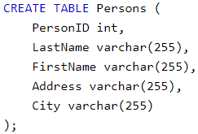

Creating a table called persons with a column that can accept the followed character type and 255 characters

VARCHAR (x) – varchar can contain any type of character with x character limit
Char (x) – can contain any type of character with only x character length
Declare statement is reference to a certain statement, and is used in the body of the program
- Deletes the table called shippers
- Deletes the data inside the table, but not the table itself
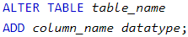
To alter a table, by add/drop column

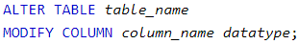
Modifies data-type of column for a certain table

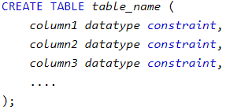

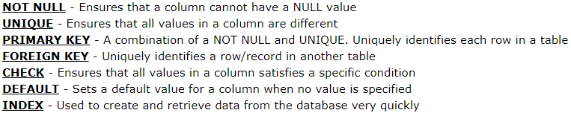
Type of constraints
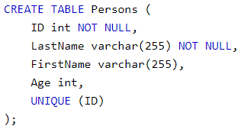
- Programming the certain columns to have constraints

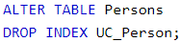
- Delete for 1 column

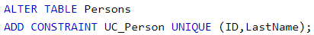
Adding unique constraint for ID and Last Name

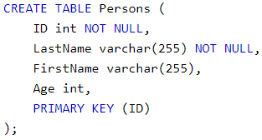
Setting the primary key to 1 column (ID)

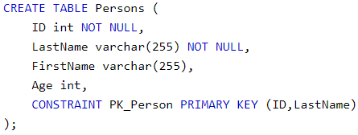
Keep 2 columns (ID and LastName) as the primary keys

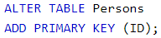
Add/Drop a primary key to a different table

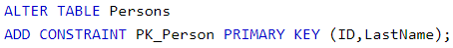
Add/Drop multiple primary keys to a
different table

A FOREIGN KEY is a field (or collection of fields) that links 2 tables, where in one table that refers to the PRIMARY KEY in another table.

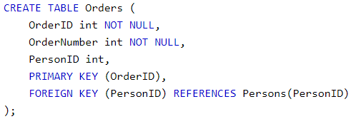

Order ID – Not Null
Order number – Not Null
Person ID – integer
Primary Key – OrderID
PersonID is the foreign key which is present in persons table

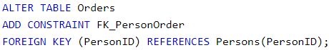
Alternate table adding a constraint on the foreign key

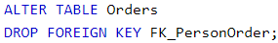
Deleting a foreign key from an alternate table

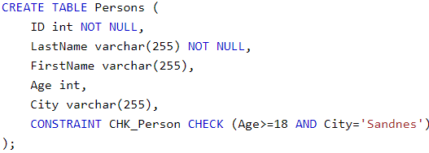

This constraint checks that the age is >=18 and the city is sandness

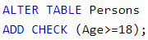
Add/drop check the condition in an alternate table

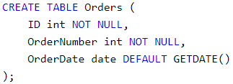

Date gets set by default when the table is created

Defaults – If no other value is given, a certain value provided will be the default

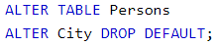
In the alternate table, the city column to drop by default

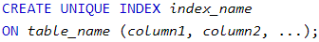
Create a unique index for certain table
If a unique index, isn't required remove the word unique and use the same function

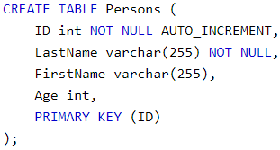
Auto_Increment is a feature which auto increases each value starting from 1 by each record

Primary Key is an auto_increment value

Use this function is the value is required to start at a certain number

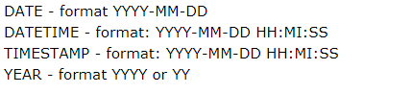
The types of date formats and the relevant code

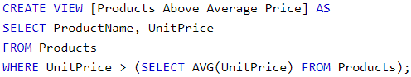
Create view is a custom view of a sample part of the database for testing

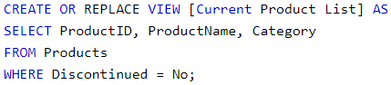
- This function allows the view to be created or updated

SQL Injection
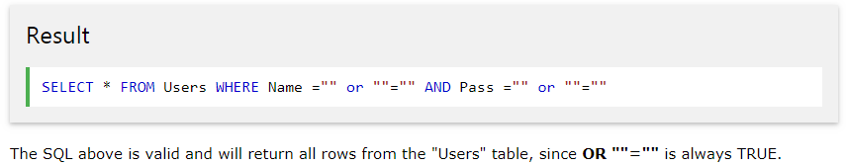
This is a type of code that can be entered by a user to add, modify, or delete codes without permission. People create codes to block users from hacking their database, such as using the functions below

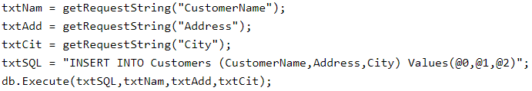
This restricts the values from being used as a function. For example: @value can't be replaced with a function since it has @ and is followed by others. getRequestString(“blabla”) is also another prevention
INSTR
Searches 3 in W3schools.com and give the position of the first 3 it finds
Character_Length
Mentions character length. Char_Length is also another substitute
Concat_WS will give a common character(s) between the strings
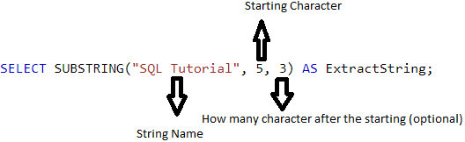

Normalization
Software Learnt

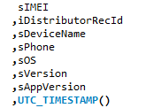
The small letters are used to indicate (reference) what type of characters are allowed, such as s – string, i-integer, b-Boolean

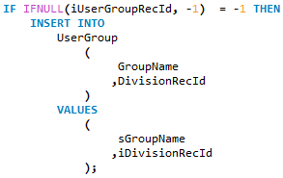
When creating a new record, value will be null. Therefore replaced with -1 in ifnull function. Then creates a new record for it based on another code.

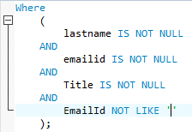
This code makes sure: lastname, email, and title is not null. Also checks that the emailid is not a blank one.
Didn't Understand
https://www.w3schools.com/sql/sql_any_all.asp

